Adaptive Learning Skill:
Removing Staples

Materials Needed:
- Paper (to make packets)
- Stapler (for prep purposes only)
- Staple remover
- Tray to sort paper into (optional)
- Laminate (optional)
- CLC Video (Included)

Introduction/ Discussion:
Adaptive skills come from adaptive behavior, or the conceptual, social, and practical skills that individuals have learned and use in their daily lives.

Preparing students for independent living. One aspect of this is building skills that can help transition into work! Removing staples not only builds practical office skills, but also works on fine motor development! While removing staples you can discuss how

Activities:
- Discuss the activity for the day and why it is important.
- Review the visual describing the steps of the process.
- Model the task
- Have the student complete the task, independently or with /prompt support.

Review/ Summary:
- Discuss the steps of the process.
- Walk the student through one round of the task and have them repeat until finished

Sirius’ TA for removing staples

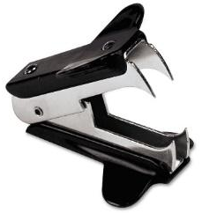
Get the staple remover Get a stack of papers

Take one packet Find the staple

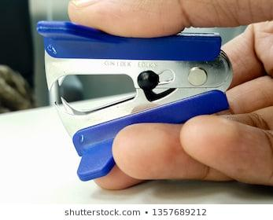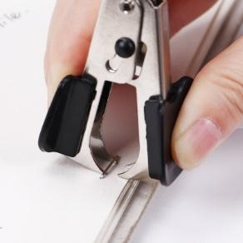
Get the staple remover Place pokey part under the
staple and squeeze it closed

Pick up the papers Put the papers in the bin

